**RWANDA FOOD AND DRUGS AUTHORITY OPERATIONALIZATION AND CONCEPTUALIZATION: A TIME SERIES ANALYSIS**

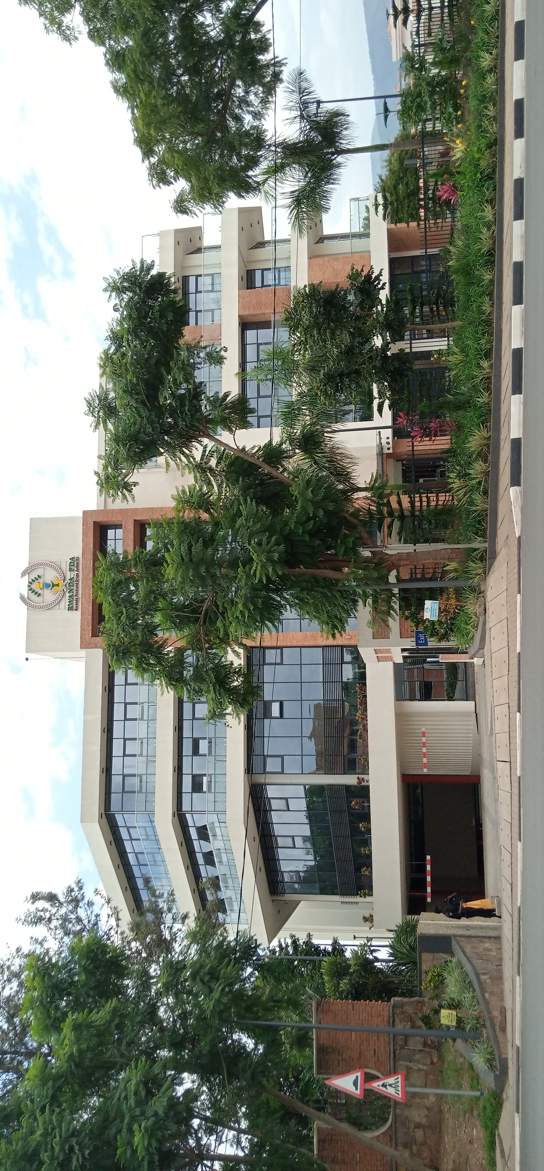

# I. Background

Rwanda Food and Drug Authority (Rwanda FDA) was established in 2018 and is mandated by the Law No 003/2018 to protect public health by regulating human and veterinary medicines, vaccines and other biological products, and processed foods. Rwanda FDA started its operations in July 2018.

For the Authority to measure its progress towards its operationalization and achieving its regulatory mandates, monitoring and evaluating its operationalization and activity implementation is essential and required to measure progress.

# II. Overall Aim

The present analysis intends to track the Authorities growth curve towards its operationalization and attaining its regulatory mandates and identify gaps which could impede the long-term-success of the institution and project its growth trajectory.

# III. Methodology

A desk review will be conducted to collect data on regulatory and support functions from all the departments and Units. Data will be collected from all Rwanda FDA documents and archives from the Office of the Director General, Inspection Department, Registration Department, Office the Chief Finance and the Quality Control Laboratory Division. Data will be corrected on Authority’s developed regulatory documents, generated revenues, registered medical and food products, inspections conducted, products safety and pharmacovigilance, capacity building of staff, human resources and management, products sampled and tested and infrastructure and equipment. Data will be analyzed using the applicable statistical software.

The analysis will cover all operations of Authority **From the year July 2018 to February 2021 as structured and guided below:**

## Structure and Human Resources

* Infrastructures (office, equipment, machinery, vehicles etc….)
* Human resources development

## Documentation

* Laws
* Technical Regulations developed and published (Baseline)
* Guidelines developed and published (Baseline)
* Archives

## **Assessment and Registration of regulated Products)**

Rwanda FDA has two divisions under Food and Drugs Assessment and registration Department:

### **The Division of Drugs and Health Technologies Assessment and Registration**

This Division is made of 23 assessors who offers the service of assessing and registering human and veterinary medicines, human and veterinary biologicals and vaccines, human and veterinary medical devices, herbal medicines, medicated cosmetics and laboratory and cleaning chemicals and pesticides.

#### **Dossiers received for registration**

Since the starting of products registration till April 2021, Rwanda FDA has received 1952 dossiers from different types of pharmaceutical products. The document submitted frequently were applying the registration of human medical product with 89.3% of the total received dossiers as shown in below figure.

From the dossiers received for registration; 41% of human medicines received in 2019, 80% of Medical Devices & IVDs received in 2020, 33% of Herbal medicines received in 2019, 62% of hand sanitizer received in 2020, 100% of disinfectants received in 2020, 100% (50:50) of cosmetics received in both 2020 and 2021 respectively, 50% of pesticides received in 2020 and 90% of veterinary medicines were received in 2020 as presented below:

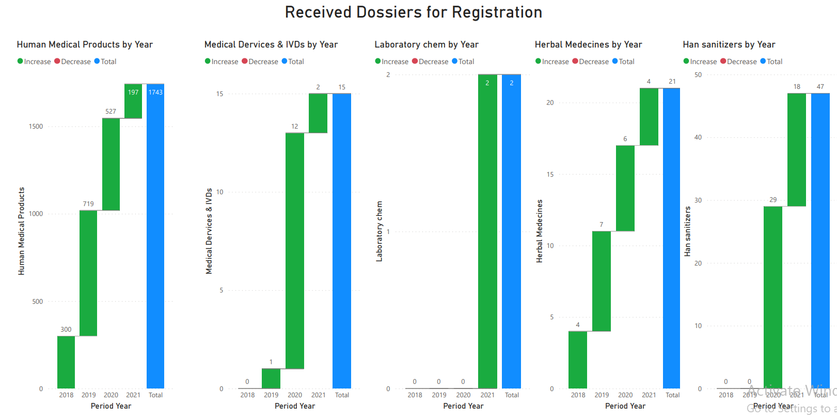

.

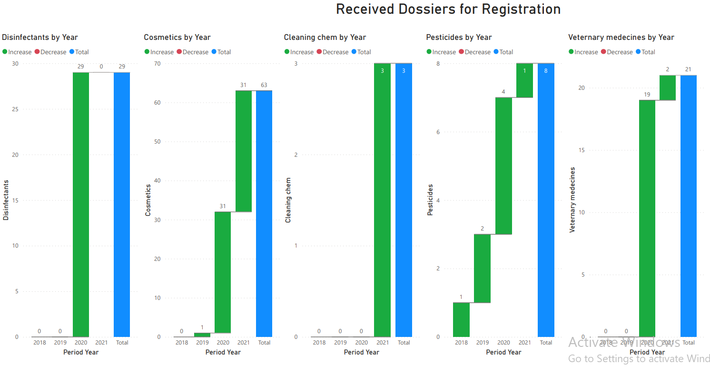

#### **Dossiers Assessed for registration**

Since the starting of products assessment for registration till April 2021, 426 (22% of 1952 dossiers received from different types of products) were assessed. In the overall assessed documents, 66% were Human Medical Products, However 44% is for the remaining products based assessment as shown in the figure below

Among the dossiers assessed toward registration; 44.5% of human medicines were assessed in 2018, 75% of Medical Devices & IVDs assessed in 2020, 100% of Herbal medicines assessed in 2019, 77.5% of hand sanitizer were assessed in 2020, 90% of disinfectants in 2020, 87.5% of cosmetics assessed in 2020, 62.5% of pesticides were assessed in 2020 and 90.5% of veterinary medicines were assessed in 2020 as shown in the figure below: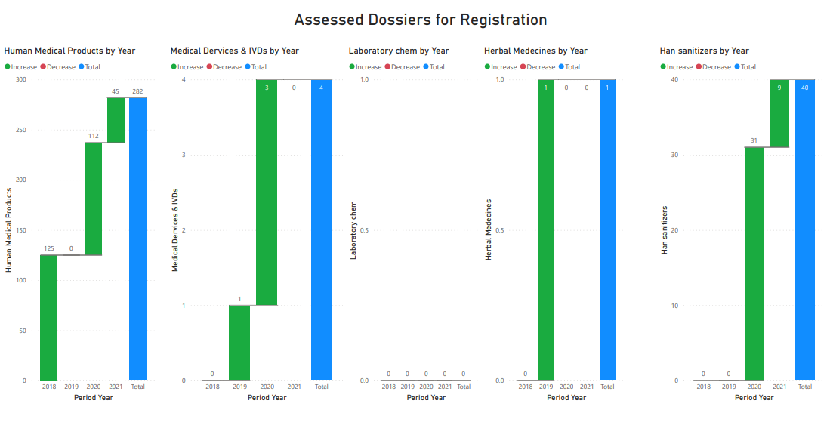

Figure: Assessed dosiers2 1

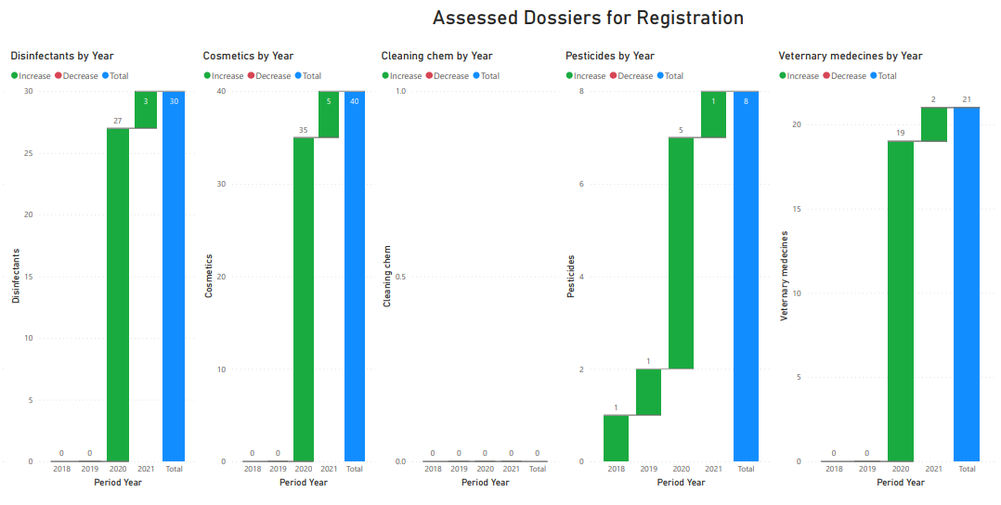

Figure: Assessed dosiers2 1

The above figures show that there is no document about Laboratory Chemicals and/or cleaning chemicals assessed since the beginning of Rwanda FDA operations

#### **Registered Products**

Since the starting of products assessment for registration till April 2021, 109 products (25.5% of 426 dossiers assessed from different types of products) are now registered under Rwanda FDA License. In the overall registered products, 98(90%) are Human Medical Products, while the remaining 10% is for registered Medical Devices, Hand Sanitizer, pesticide and veterinary medicines. This means that there is no registered products for: Laboratory chemicals, Herbal Medicines, Disinfectants, Cosmetics and Cleaning chemicals.

Regarding Human Medicines, Rwanda FDA has developed the list of authorized human medicines in order to monitor the sufficient of all required medicines in our country. The number of authorized human medicines is 4522 medicines which can be found on Rwanda FDA website.

The ratio between documents received, assessed and registered products since the Rwanda FDA Operation.

#### **Rate of document assessment towards registration**

The results of analysis shows that a product can be assessed in year A and be registered in year B or C depending on the additional information that an assessor requested to the sponsor/client. For instance in 2018 Rwanda FDA Assessors assessed 126 products and register 22 products, however in 2019, the Rwanda FDA Assessors assessed 3 products and registered 23 products. This means that the 20 products registered are among the 126 assessed in 2018.

Therefore through the development of the Authority here is the presentation of assessment and registration process along the four years.

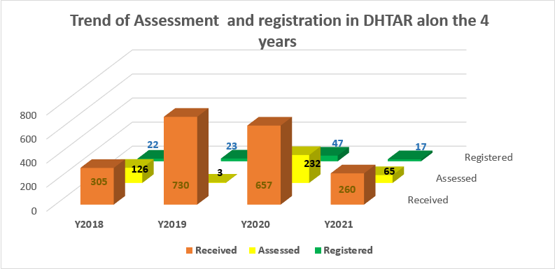

From the routine of the work, the assessment of one dossier involves two assessors. However, based on cumulative evolution of Rwanda FDA assessors from the division of DHTAR; In 2018 Rwanda FDA had 2 assessors, in 2019 the number of assessors get 13 and in 2020, the number become 15 assessors.

#### **Identified Gaps in the process common causes of delays**

### **Division of Food and Drugs Assessment and Registration**

This Division is made of 15 assessors who offers the service of assessing and registering processed food/ drinks, food supplements, food additives and tobacco products. When all required documents and samples have been submitted, it takes between 1 and half to 2 months to get registration.

#### **Dossiers received for registration**

Since the starting of products registration till April 2021, Rwanda FDA has received 1227 dossiers, 1194(97.3%) of them were assessed, while 241(20%) of the assessed were registered from different types of food products. The document submitted frequently were applying the registration of food and Beverage products with 87.7% of the total received dossiers as shown in the figure below.

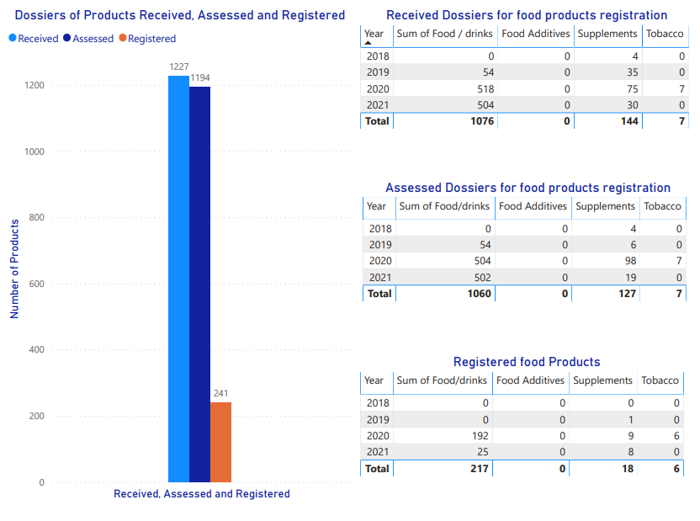

* Clinical Trials

## Import and export control

Rate of service delivery for licensing; Utilization of PRIMS

Import & export licenses (for all different regulated products including medicines, food and others including VISA where required)

## Premise and operational licensing

For both wholesales and retails food and veterinary/human Pharmaceutical products, Rwanda FDA established a procedure to follow before starting and during operations. It starts by premise licensing which approves a specific location, and grants/authorizes the holder to carry on any of the following licensable activities: the sale of Beverages, food, the supply of beverages by a club to its members and guests, Drugs, vaccines, Optical products, orthopedic and sanctioned company.

#### Food industries

Before Rwanda Food and Drugs Authority starts to operate, there was various food industries in different provinces of Rwanda, after being established by **law nº 003/2018 of 09/02/2018 establishing Rwanda food and drugs authority and determining its mission, organization and functioning,** Rwanda Food and Drugs Authority initiated the process of mapping all local industries starting with local food manufacturers in order to inspect and monitor them. As of April 2021, trough mapping activities and reports, Rwanda FDA inspectors mapped 696 food industries along the country. From the total mapped food industries, only 89(12.7%) licensed for premise and operating.

The distribution of mapped industries and licensed industries along the five provinces of Rwanda is as below:

* Inspections conducted on regulated products for regulatory compliances (No Inspection reports/**classification of offenses or non-compliances/regulatory actions taken**

#### Pharmaceutical industries

Rwanda FDA is responsible for establishing and licensing all local pharmaceutical industries. The Authority has established the inspection schedule for monitoring all regulated industries.

##### Inspected and Licensed Pharmaceutical Companies

Since the beginning of Rwanda FDA operations to end of March 2021, Rwanda FDA inspected and licensed 578 human retail pharmacies, 143 human wholesales Pharmacies, 3 online pharmacies and 13 small compounding facilities (small scale manufacturing companies) as represented in the figure below:

##### Distribution of Licensed and Inspected Pharmaceutical Companies

Through monitoring the report of inspected and licensed premises, from July 2018 to March 2021, The Authority has recorded premises with the confirmed date of operating under the following distribution along the country:

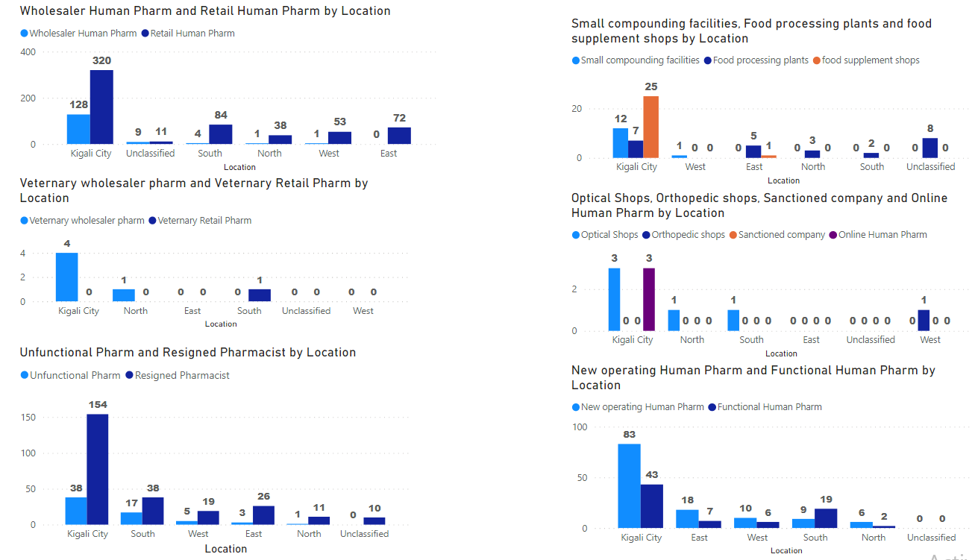

1. Distribution of Local premises with Confirmed time as still operating

|  |  |  |  |  |  |  |  |
| --- | --- | --- | --- | --- | --- | --- | --- |
| Category | | 2017 | 2018 | 2019 | 2020 | 2021 | UnClasy |
| Wholesaler Human Pharm | | 0 | 84(  Kgl= 78  N= 1  S=4  W=1  E= 0  ) | 1(  Kgl=1) | 10(  Kgl=10) | 2(  Kgl=2  ) | 37 (  Kg=37) |
| Retail Human Pharm | | 338 (  Kgl= 201  N= 26  S=46  W=32  E= 33  ) | 0 | 1 (NA Province) | 69 (  Kgl= 38  N= 2  S=4  W=8  E= 16  NA=1  ) | 14  Kgl= 6  N= 3  S=2  W= 2  E= 1  ) | 147(  Kgl= 75  N= 7  S=32  W=11  E=22) |
| Online Human Pharm | | 0 | 0 | 0 | 2 (  KGL=2) | 1 | 0 |
| Small compounding Facilities | | 0 | 0 | 0 | 9 (  Kgl=7  S=2) | 4 (  KGL= 3  E=1) | 0 |
| Food supplement shops | | 12(  Kgl=12) | 7 (  Kgl=7) | 1 (  Kgl =1) | 6 (  Kgl=6) | 0 | 0 |
| Veterinary Retail pharm | | 0 | 0 | 0 | 1 (  E=1) | 0 | 0 |
| Veterinary wholesaler pharm | | 0 | 0 | 0 | 0 | 0 | NA (  Kgl =4  N=1) |
| Food processing plants (Issue & Expiry Year) | | 2018-2019 | | 2019-2020 | | 2020-2021 | UnClasy |
| 0 | | 1 (  N=1) | | 4(  Kgl=2  E=2  ) | 20 (  Kgl=5  E=3  N=2  S=2  NA=8) |
| New operating Human Pharm | | 0 | 1 (  Kgl =1) | 35 (  Kgl=30  E=2  S=1  W=2) | 77  (Kgl=46  E= 15  S=6  W=7  N= 3) | 13  (Kgl=6  E= 1  S=2  W=1  N= 3 ) | 0 |
| Functional Human Pharm | | 8 | 3 | 0 | 2 | 0 | 64 (KLG=38,N=1,S=17,E=3,W=5 ) |
| Un-functional Pharm | | 0 | 0 | 0 | 0 | 0 | 64(  Kgl= 38  N= 1  S= 17  W= 5  E= 3 ) |
| Resignation Pharmacist | District Hospital | 0 | 0 | 1(  Kgl =1) | 0 | 0 | 0 |
| Food supplement shops | 0 | 0 | 0 | 1(  Na=1) | 0 | 0 |
| Hospital pharmacy | 0 | 0 | 1 (  Kgl =1) | 0 | 0 | 0 |
| Retail | 72(  Kgl=25  E=13  N=3  W=7  S=19  NA=5) | 18(  Kgl=10  E= 3  N=2  W=1  NA=2) | 51(  Kgl=31  E= 7  N=2  W=3  S=8 | 65(  Kgl=44  E=3  N=3  W=7  S=8) | 0 | 0 |
| Wholesaler | 22(  Kgl=20  S=2) | 2(  Kgl=2) | 15 (  Kgl=13  N=1  S=1) | 9 (  Kgl=7  W=1) | 0 | 2(  NA=2) |
| Optical Shops | | 0 | 0 | 0 | 1 (  Kgl=1) | 3 (  Kgl = 1  S = 1  N=1) | 1 (  Kgl=1) |
| Orthopedic shops | | 0 | 0 | 1 (  W=1) | 0 | 0 | 0 |
| Sanctioned company | | 0 | 0 | 0 | 0 | 0 | 0 |

1. Ff

* Retail and Wholes sale outlets (Baseline By province/District)
* Retail optical and food supplement outlets (Baseline by province/District)
* Veterinary medicines Pharmacies (Baseline By provinces/District)

### Applications received for regulated Products registration and Clinical trial investigations

**FRJTJIUmmmm**

### Adverse Drug Reaction

* Number of ADR report to Rwanda FDA/reported to Uppsala monitoring center

### Post market surveillance (samples sampled and test/reports/classification of severity of events/regulatory actions taken

wgjrgrhjmujhwjktle

#### The parameter tested frequently for Medical products

#### Parameter tested frequently for food products

lihuujhhju

#### Critical parameter to be tested for medical products

#### Critical parameter to be tested for food products

Ghtgyjyjjtkhh

* Recalled products/quarantined/ deregistered and circulars (regulated products/year)

## Finance

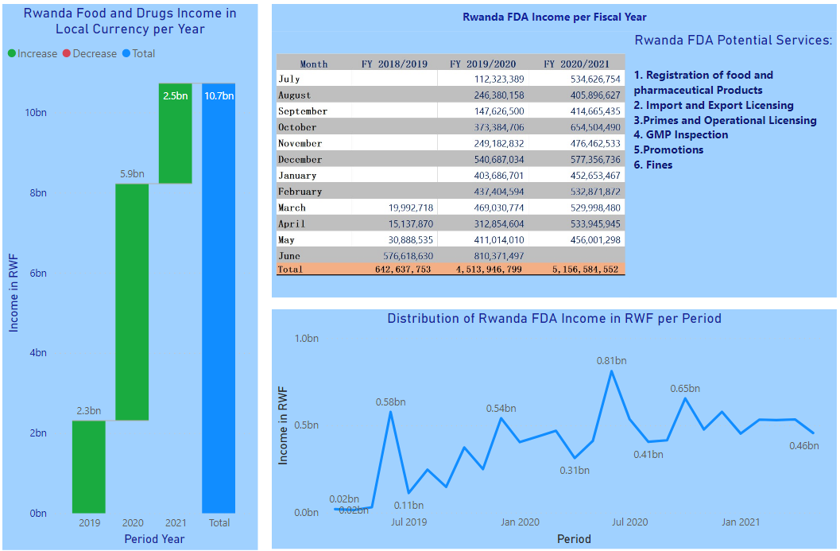

* Assets

The proposed analysis will also evaluate the current turnaround time of delivering services related to Rwanda FDA’s regulatory requirements compliance and try to identify the main possible of causes of.

# IV. Significance and outcomes

The trend of the performance of the Authority will be plotted against the identified data to indicate its performance and thereafter, a prediction for the future determined for guidance to the Authority.

The findings of the analysis will guide the Authority’s strategic planning towards regulatory compliance and services delivery. The analysis will further inform the Authority on the impact of the regulatory functions on the public health protection and clients.

Key Implementable recommendation for improvement will be proposed for the Authority’s considerations.

# V. Resources

The analysis will not need resources in terms of finance but will need time and people in different departments, divisions and Units to facilitate the data gathering analysis and interpretation.

# VI. Request to SMT

Individual department, Division or Unit to designate a focal person to avail all information to the team that will be conducting the data collection.

END

::::::::::::::::::::::::::::::::::::::::::::::::::::::::::::::::::::::::::::::::::::::::::::::::::::::::::::::::::::::::::::::::::::::::::::::::::::::::